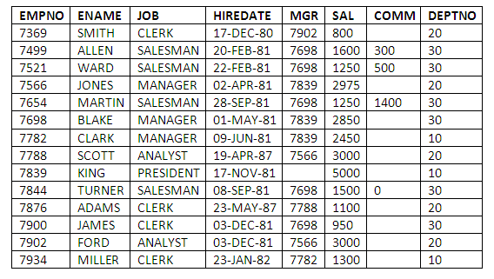**DBMS LAB PRACTICE QUESTIONS-02**

1. **Create the table Employee and department table with the necessary integrity constraints with the**

**following**

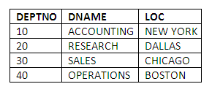

1. Display the all the employee name from the employee table.
2. Display all the rows from the department table.
3. Display the employee number , employee name , sal and commission from the employee table.
4. Display the employee number, name of the employees with the 12% of the monthly commission to the salary.
5. Display employee number, employee name and hire date where hire date is less than the ’01-may-1981’;
6. Display the employee no, name and job and salary whose job is sales man.
7. Display the unique jobs in employee table.
8. List the entire employee who does not earn more than 1500.
9. List all employees who are not manager.
10. Find the Deptno 10 employees Avg Salary.
11. Find the Average salary of Salesmen.
12. Find the total annual pay for a managers and display result with the name of ANNUAL_SAL
13. Find the sum of the salaries of all employees, the maximum salary, the minimum salary, and the average. Salary. Display with proper headings.
14. Find the sum of the salaries of all employees, the maximum salary, the minimum salary, and the average. Salary. Display with proper headings.